**ASSIGNMENT 20a – VOLUME AND CAPACITY OF PRISMS**

1) Calculate the volume and capacity of the following prisms.

a) A rectangular prism with a base of 17.5 cm by 13.2 cm and the height is 18.8 cm.

Formula for Volume: V = l x w x h and V = Abase x h

= 17.5 x 13.2 x 18.8

= 4342.8 cm^3/1000

= 4.34 L

b) A rectangular prism with a square base with sides of 2.75 ft. and a height of 5.8 ft.

Formula for Volume: V = Abase x h and V = l x w x h

= 2.75 x 2.75 x 5.8

= 43.86 ft^3 = 1336.85 (into cm)

= 1336.85/1000 = 1.34 L

2) A rectangular prism has a base of 6.9 cm by 8.8 cm. If the volume is 212.5 cm3, what is the height of the prism? Answer to one decimal place.

Formula for Volume: l x w x h and V = Abase x h

= 212.5/6.9/8.8

= 3.5 cm is the height

= 212.5/1000

= 0.21 L

3) One rectangular prism has dimensions of 8 mm by 12 mm by 20 mm. A second prism has a base of 32 mm by 6 mm. What must the height of the second prism be so their volumes are the same?

Formula for Volume: l x w x h and V = Abase x h

= 8 x 12 x 20 = 1920 cm^3

= 1920/32/6

= 10 mm is the height for the second prism

= 1920 cm^3/1000

= 1.92 L

4) A hole, 18 m by 8 m by 5 m, is being dug in a backyard to make a swimming pool. A dump truck can only carry 12 m3 of dirt. How many trips will the truck have to make to remove the dirt for the pool?

Formula for Volume: l x w x h and V = Abase x h

= 18 x 8 x 5 = 720 m^3

= 720/1000 = 0.72 L of dirt

= 720/12 = 60 trips the truck will have to make.

**ASSIGNMENT 20b – VOLUME AND CAPACITY OF CYLINDERS AND CONES**

1) Calculate the volume and capacity of a cylinder with a radius of 27 cm and a height of 45 cm.

Formula for Volume: 3.14 x r x r x h and V = Abase x h

= 3.14 x 27 x 27 x 45

= 103007.7 cm^3/1000

= 103.01 L

2) A large cylinder has a capacity of 4.25 L. If the cylinder has a *diameter* of 13 cm, what is the height of the cylinder? Use page 28 as a guide!

Formula for Volume: 3.14 x r x r x h

= 4.25 L x 1000 = 4250 cm^3 (volume of cylinder)

= 13/2 = 7.5 = 4250/3.14/7.5/7.5

= The height is 24.06 cm

3) Find the volume of a cone with a radius of 5 inches and a height of 14.5 inches.

Formula for Volume: 1/3 x 3.14 x r x r x h and

= 3.14 x 5 x 5 x 14.5/3

= 379.42 in^3

4) A cone has a radius of 15 mm and a volume of 5890.5 mm3. What is the height of this cone? Use page 28 as a guide!

Formula for Volume: 1/3 x 3.14 x r x r x h and

= 5890.5 x 3/3.14/15/15

= 25.01 mm is the height

= 5890.5

5) Which has a greater volume – a cylinder with a radius of 2.5 cm and a height of 16.7 cm or a cone with a diameter of 4 in. and a height of 6 in.? Hint: 1 inch = 2.54 cm.

Formula for Volume (Cylinder): 3.14 x r x r x h and V = Abase x h

Formula for Volume (Cone): 1/3 x 3.14 x r x r x h and V = Abase x h

(cylinder) = 3.14 x 2.5 x 2.5 x 16.7 = 327.74 cm^3

(cone) = 4/2 = 2 x 2 x 6 x 3.14/3 = 25.12 x 2.54 = 63.80 cm^3

The cylinder has a greater volume.

**ASSIGNMENT 20c – VOLUME & CAPACITY OF PYRAMIDS AND SPHERES**

1) Calculate the volume of the pyramid and the prism below. Include the formula as part of your answer. ***What is the difference in their volumes***?

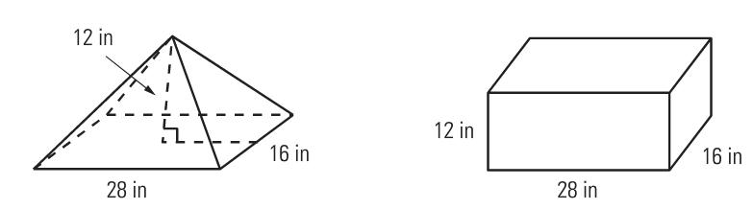

Formula for a Pyramid: 1/3 x l x w x h

Formula for a Cube: 2lh + 2wh + 2lw

(Pyramid) = 12 x 28 x 16/3 = 1792 in^3

(Cube) = 12 x 28 x 16 = 5376 in^3

The difference in their volumes is that for the formula for the pyramid, you just divide by 3 where is both figures, the formula is l x w x h.

2) Calculate the volume of the following pyramids. Write the formula as part of your answer.

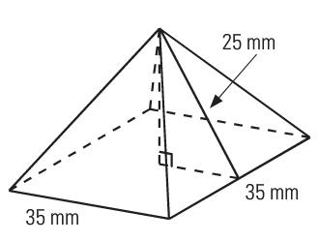a) b)

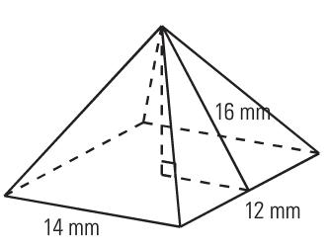

a) Formula for a Pyramid: 1/3 x l x w x h

= 35/2 = 17.5 = 25 x 25 – 17.5 x 17.5 b) Formula for a Pyramid: 1/3 x l

= Square Root of 318.75 = 17.85 (the height) x w x h

= 25 x 17.5 x 17.85/3 = 2603.13 mm^3 = 14 x 12 x 16/3 = 896 mm^3

3) Find the volume and capacity of the Omnimax Theatre at Science World, which is almost a sphere with a radius of 25 m. (Hint: 1m3 = 1000 L)

Formula for a Sphere: 4/3 x 3.14 x r^3

= 25 x 25 x 25 x 3.14/3 x 4 = 65416.68 m^3

= 65416.68 x 1000

= 65,416,680 L

4) What is the capacity, in gal (US), of a water tower shaped like a sphere with a diameter of 28.4 feet? Remember, 1 ft3 = 7.48 gal (US).

Formula for a Sphere: 4/3 x 3.14 x r x r x r

= 28.4/2 = 14.4 x 14.4 x 14.4 x 3.14/3 x 4

= 12,501.32 ft^3 x 7.48

= 93,509 gallons (US)

5) Tennis balls are usually sold in containers shaped like cylinders. One such containers holds 3 tennis balls each with a radius of 3.5 cm. What is the volume of one tennis ball, and what is the volume of the container?

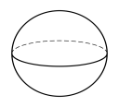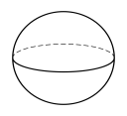

Formula for a Sphere: 4/3 x 3.14 x r x r x r

= 3.14 x 3.5 x 3.5 x 3.5/3 x 4

= 134.63/3 x 4 = 179.52 cm^3

= 179.52 x 3 = 538.56 cm^3

The volume of one tennis ball is 179.52 cm^3 and for the whole container, the volume is 538.56 cm^3.